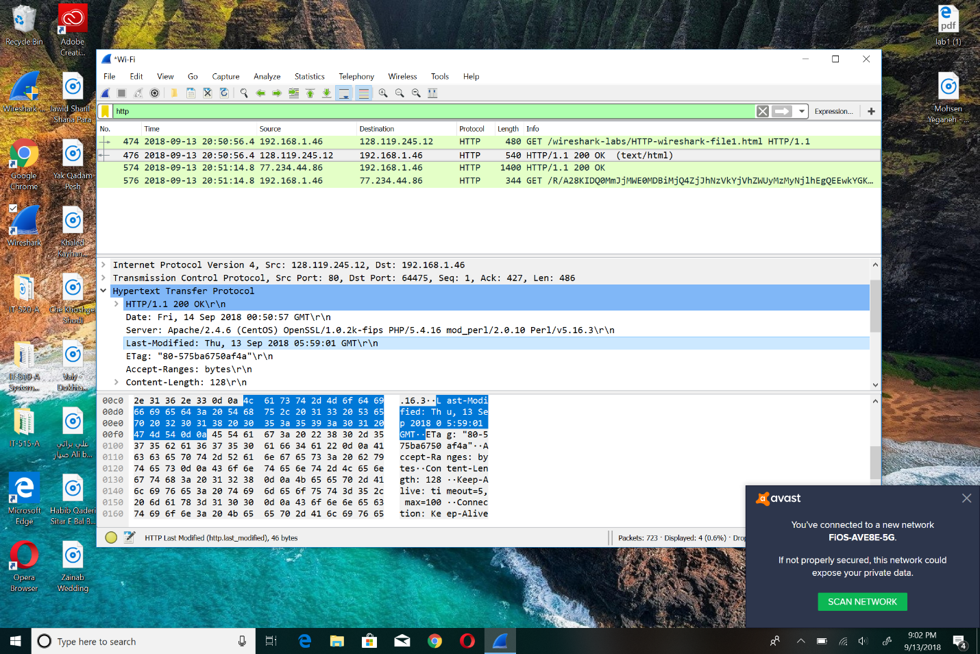2: The HTML was last modified on Thursday, September 13, 2018.